TC-850PD1 ( iSTAR USA版本 )
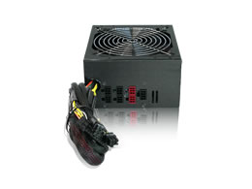
- Complies with ATX 12V 2.0 Version
- Independent Voltage Circuit
- SLI and Cross-Fire Ready
- Industrial Grade Components (Capacitor, Transformer, and etc)
- High Reliability: MTBF>120,000 hours
- SATA and PCI-E Ready
- Protection: Over Current, Over Voltage, Short-Circuit, Under Voltage, Overload, and Over-temperature
- Modular Interface for a Clean Look and Better Airflow
- 120mm Low Noise Ball Bearing Fan with Honeycomb Cut Providing Ultimate Quiet
The TC-850PD1 high performance switching power supply supports latest motherboard connectors of 20, 24, 8, and 4 pins. It sets new standard in server and industrial power supply. In addition, TC-850PD1 comes with four PCI-Express connectors to enable SLI and Cross-Fire application and six SATA power connectors for the latest storage interface. Modular interface gives TC-850PD1 a clean look and better airflow and 80plus high efficiency power supply saves on electric bills and less cooling requirement. TC-850PD1 is the ideal power supply for server and high-end gaming workstation.

